An investigation into the practical uses of spherical non-Euclidean geometry in games

Is spherical non-Euclidean geometry in the Unity game engine practical?

January 30, 2022

Iain Farlow, s1903434

University of Gloucestershire

Contents

1 Introduction 2

1.1 Justification 2

1.2 Aims 3

1.3 Objectives 3

2 Literature Review 3

2.1 Overview 3

2.2 Euclidean Geometry 3

2.3 Non-Euclidean Geometry 4

2.3.1 Examples of Non-Euclidean Games 4

2.3.2 Hyperbolic Non-Euclidean Geometry 6

2.3.3 Spherical Non-Euclidean Geometry 6

2.4 What can Spherical Non-Euclidean Geometry bring to the Games Industry 6

2.5 Summary 6

3 Output Design 6

3.1 Overview 6

3.2 Possible Issues 6

3.2.1 Level Creation 6

3.2.2 Rendering 7

4 References 8

Table of Figures

Figure 1: The Difference Between Euclidean and Non-Euclidean Geometry (Kurniadi, 2011). 2

Figure 2: Poincaré Disk (left) and Beltrami-Klein(right) projections of the Hyperbolic Maze (Madore, N.D). 5

Figure 3: Octahedral holonomy maze (Segerman, N.D). 5

# Introduction

## Justification

The problem that is being investigated is that of ‘Can non-Euclidean geometry be practical in the creation of a 3D game?’. Euclidean geometry is defined by a collection of rules as set out in “The Elements” (Euclid, 300 bce) and has formed the basis of geometry in all modern society, see *figure 1 ‘zero curvature’*. As a result of Euclidean geometry being a key aspect of society, it has an influence on video games as well, “Since the conception of the first video game, its visual representation has always been done mainly in the fashion of the Euclidean geometry.” (Guimaraes, Mello & Velho, 2015).

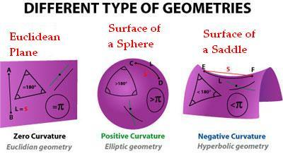

Figure 1: The Difference Between Euclidean and Non-Euclidean Geometry (Kurniadi, 2011).

Wolf (2018) states that “video games can easily allow for non-Euclidean configurations”. However, Taylor (2003) also says “In keeping with these cultural prejudices, descriptions of the optical space of video games presume an uncomplicated optical scheme, founded on traditions of linear perspective.” This suggests that, despite non-Euclidean geometry being, theoretically, easy to implement, a complicated form of non-Euclidean geometry needs to be done to a high quality to be successful. Currently, to make games intuitive and familiar to players the industry heavily relies on the conventions set out in film and television (Wolf, 2004) this means that games designers have neglected the possibilities that abstract design methods provide. This has the potential to be one of the key aspects of why there is a lack of games that utilise non-Euclidean geometry.

The output design will involve, but not be limited to, an environment containing a procedurally generated maze that is created in a spherically non-Euclidean world. In this a basic character controller will be present, allowing for the movement within the maze. However, there is no intent to have any gameplay elements present, such as UI or a formal gameplay loop. However, this is anticipated to change as development progresses.

## Aims

This paper aims to investigate the uses, and potential uses, of spherical non-Euclidean geometry, research why non-Euclidean geometry is typically not used in video games, and try to establish a viable method for the implementation of a spherically non-Euclid geometry in the Unity game engine (Unity Technologies, 2020).

## Objectives

* Conduct a review of academic literature regarding non-Euclidean geometry.
* Research and evaluate the uses, and potential uses, of spherical non-Euclidean geometry in the industry.
* Determine a system for simulating spherical non-Euclidean geometry.
* Create a program in the Unity game engine (Unity Technologies) using said system.

# Literature Review

## Overview

This literature review will investigate how computers can simulate Non-Euclidean Geometry. With this, the methods of simulating Non-Euclidean Geometry will be compared whilst also analysing their practical uses within video games. This will then be used to justify the use of Spherical Non-Euclidean Geometry as a viable form of Geometry in games.

## Euclidean Geometry

Euclidean Geometry is the typical form of geometry most people are used to. In this form of geometry, the world around us is mapped onto a plane with no curvature. With this “Each ordered pair (p1, p2) of real numbers determines exactly one point P of the plane. The point determined by (0, 0) is called the origin” (Ryan, 1986). This is the basic coordinate system that we interpret our flat geometry in, with a third real number being used to allow us to interpret in a third dimension. This allows for people to interpret the transform of something with relative ease due to the 2 / 3 axes being easily interpreted. This is especially the case when computers are involved, as the use of transformation matrices allow the storing of data that not only stores the position of an object, but also its rotation and scale.

Due to the flat nature it

Angles in triangle add to 180.

## Non-Euclidean Geometry

### Examples of Non-Euclidean Games

Hyperbolica (CodeParade, 2022) is a Game that utilises non-Euclidean geometry in both Spherical and Hyperbolic form. This is an example of how games can work in a non-Euclidean format. Showing, that whilst the standards of the industry are to present games in a Euclidean geometry, it is not only possible to make a game in non-Euclidean geometry but possible to have positive feedback from the community surrounding the game. However, due to Hyperbolica’s small development team it is obvious in the game has a very small scope. Despite this, the game is a very high-quality example of how various forms of non-Euclidean geometry can be used. Showing gameplay in various situations such as a shooting, flying and quests, proving that non-Euclidean geometry in practical in various situations.

A highly successful example of a non-Euclidean game series is the Portal Game series. The Portal games offer the non-Euclidean experience through the use of portals. These can be placed on surfaces and when passed though move the player to a different part of the map (where they placed the other portal). This means that whilst the world is Euclid (no curvature) the use of portals means the game cannot be interpreted in a world such as ours due to the inconsistency caused. This is due to the fact that in a games such as Portal (Valve, 2007) or Portal 2 (Valve, 2011), the use of a portal can make distances and angles inconsistent, for example, if a point is 20 metres away from the player and they place a portal at that point, as well as one at 1 metre away from them, then they are both 20 metres and 1 metre away from the point. This is where the non-Euclidean aspect of the games appears. With these inconsistencies it is believable that the non-Euclidean nature of the could have cause audiences to find the game confusing, however, the Portal (Valve, 2007), holds extremely good reviews. Metacritic has awarded the game a 90 / 100 based on 27 Critic reviews, as well as a 9.2 / 10 based on 5930 user reviews. This demonstrates that games using a non-Euclidean format have the possibility to succeed in the games industry.

Another game that Utilises non-Euclidean geometry is the simple web game Hyperbolic Maze. This game shows how the use of different projections can change the resulting appearance of the game when using a Hyperbolic Geometry. In this game the user can explore a 2D, hyperbolic maze, and choose between two different projections, Poincaré Disk and Beltrami-Klein, see *figure 2.* Each projection type represents the space differently on screen. This demonstrates the importance of using the correct form of projection for the scenario, with some forms of projection being better for Spherical non-Euclidean geometry and other being better for Hyperbolic non-Euclidean geometry.

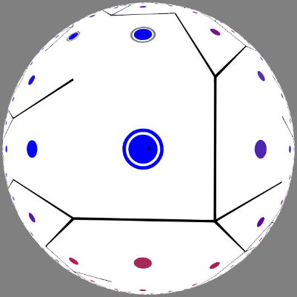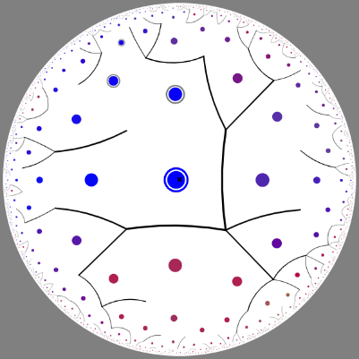

Figure 2: Poincaré Disk (left) and Beltrami-Klein(right) projections of the Hyperbolic Maze (Madore, N.D).

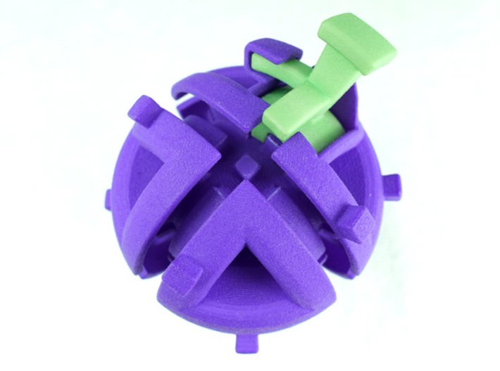

Figure 3: Octahedral holonomy maze (Segerman, N.D).

Not only aspects of non-Euclidean geometry be represented in virtual environments but also in the real world, *figure 3* shows a 3D printed maze that demonstrates the concept of holonomy. With this the green piece (rook) needs to be removed from the sphere, this can only be done by having it at the start point but with a different rotation. To achieve this the user put move the rook around the maze; due to the concept of holonomy the rook will rotate based on its movement. With the addition of the blocking pieces on the maze the user must move the rook in a specific way in order to achieve the required end rotation. This shows how non-Euclidean (curved) geometry causes rotation to be accumulated as things move along its surface.

### Hyperbolic Non-Euclidean Geometry

Movement causes rotation

### Spherical Non-Euclidean Geometry

Movement causes rotation

## What can Spherical Non-Euclidean Geometry bring to the Games Industry

## Summary

# Output Design

## Overview

Using the information gathered in the literature review of this paper a game will be created that utilises spherical non-Euclidean geometry. This geometry will contain a simple randomly generated maze that will allow the user to experience the spherical non-Euclidean Geometry in an interesting way.

## Possible Issues

### Level Creation

As a result of the Spherical Non-Euclidean nature of the game the issue will arise regarding the creation of levels may arise. At this current point the idea behind the game is that the levels will be procedurally generated, to ensure the mazes are different every time the game is played. However, due to the positive curvature found within Spherical Non-Euclidean Geometry simply designing the game in Euclidean Space and then rendering it Spherical Space issues may arise. If this is the case, then it is likely that a tile map like system will have to be created.

If a tile made is to be used, the common method of simply using x, y and z coordinates is not practical. This because the spherical plane in geometry will have to have a different number of, in this case, squares on each vertex to account for its curvature, three for spherical when flat would have four. This will in turn result in a custom coordinate system being created that will simply start at the origin and use up, down left and right to determine specific points on the geometry. If this is the case then it is likely that simple vectors will not be practical to use, due the holonomy that this form of geometry causes. If this is the case, a simple fix can be created by introducing gyrovectors to the game, which will fix these issues, primary since their translations are non-commutative.

### Rendering

As a result of the Spherical Non-Euclidean geometry in the game the method in which the game is projected will have to be changed. Since the game will use Spherical geometry, it is likely that Geometric projection will be used. The issue with this form of projection lies in rendering both hemispheres, this is because one render pass can only render one half of the geometry. If two render passes were used, one for each half of the geometry, the nature of Geometric projection will cause the line where these two render passes meet to not render, as both passes can only render up to one half of the geometry. If two vertices of each triangle are in different hemispheres to each other then the whole vertex will be discarded, resulting in nothing being drawn.

As a result of the issues mentioned Geometric projection cannot be used in this case. This resulted in the conclusion that Stereographic projection must be used as it renders the whole geometry in one pass. However, it is likely that depth issues will arise if this method is used, with these issues becoming worse the further the geometry is from the camera. To fix this, two render passes can be used, both stereographic, one rendering the closer geometry and one rendering the further.

There is still one issue that may arise when rendering the geometry for the game. This is the case due to the stereographic projection that will be used. If this form of projection does have to be utilised then the depth buffer will have to be altered to compensate for issues in the far hemisphere, as well as the joining of the two projections. To do this the two projections will be in one depth buffer, the near occupying 0 – 0.5 (mapped 0 to 0 and 1 to 0.5), whilst the far occupies 0.5 to 1 (mapped 0 to 1 and 1 to 0.5 to account for depth issues).

# References

CodeParade, (2022) ‘Hyperbolica’ (To be released), Microsoft Windows, Linux [Game]. Available At: <https://store.steampowered.com/app/1256230/Hyperbolica/>

Euclid. (300 BCE) ‘The Elements’, Available At: <https://www.google.co.uk/books/edition/The_Elements_of_Euclid/5lN1sy51SwYC?hl=en&gbpv=1&printsec=frontcover>

Guimaraes, F., D., Mello V., M., & Velho, L. (2015) ‘Geometry independent game encapsulation for non-Euclidean geometries’, [Online], Available at: <https://www.semanticscholar.org/paper/Geometry-independent-game-encapsulation-for-Guimar%C3%A3es-Mello/1a14f10aa957acfbf28f31eeb69657a976cce92c#references>

Madore, D., (N.D) ‘Hyperbolic Maze’, Web Browser [Game]. Available At: <http://www.madore.org/~david/math/hyperbolic-maze.html#explanations>

Metacritic. Portal by Valve Software. Available At: <https://www.metacritic.com/game/pc/portal>

Ryan, P., J., (1986) ‘Euclidean and Non-Euclidean Geometry: An Analytic Approach’, The Press Syndicate of The University of Cambridge

Segerman, H., (N.D) ‘Octahedral holonomy maze 1’, [Product], Available At: <https://www.shapeways.com/product/GEXKSWT77/octahedral-holonomy-maze-1-rook-sold-separately?optionId=211502590&li=shops>

Taylor, L. (2003) ‘When Seams Fall Apart, Video Games Space and the Player’, Game Studies, vol. 3, issue. 2, [Online], Available At: <http://www.gamestudies.org/0302/taylor/> (Accessed: 25 January 2022)

Wolf, M., J., P. (2004) ‘Abstraction in the Video Game’, in Wolf, M., J., P. & Bernard Perron (eds.) The Video Game Theory Reader, 1st edn. Routledge, pp. 47 – 53

Unity Technologies, (21 October), Unity3D (Version 2019.4.13f1) [Software], Available At: <https://unity.com/> (Accessed: 30 January 2022)

Valve, (2007) ‘Portal’, Microsoft Windows, Xbox 360, PlayStation 3, OS X, Linux, Android, Nintendo Switch [Game]. Available At: <https://store.steampowered.com/app/400/Portal/>

Valve, (2011) ‘Portal 2’, Microsoft Windows, Xbox 360, PlayStation 3, OS X, Linux, Nintendo Switch [Game]. Available At: <https://store.steampowered.com/app/620/Portal_2/>

Wolf, M., J., P. (2018) ‘Theorizing navigable space in video games’ Potsdam University, issue. 6, pp. 18 – 49, [Online], Available At: <https://publishup.uni-potsdam.de/frontdoor/index/index/docId/5043> (Accessed: 25 January 2022)